**SQL: Capstone Project**

## 

## NOTE:

* Perform the below exercises in your SQL editor installed on your laptop.
* You can use the links provided at the end of the exercises for extra practice.

# Session 2: Creating a Database

1.

1. Create a database with the name: AbleJobs
2. Create the following Table with the name: Sales1

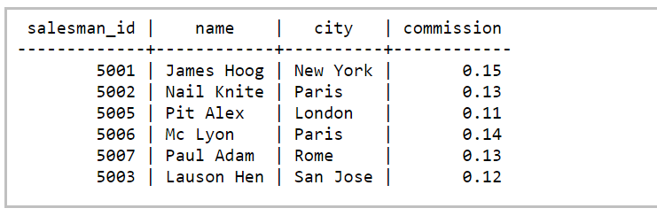

1. Display all the data in the above table

2.

1. Create a database with the name: AbleJobs
2. Create the following Table with the name: Sales2

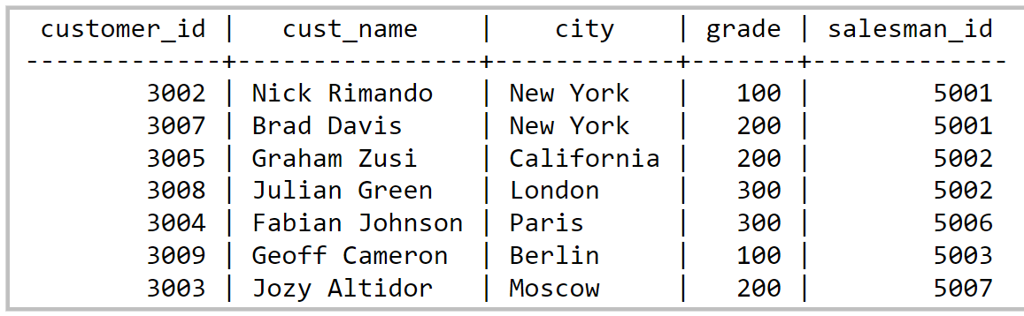

1. Display all the data in the above table

# Session 3: Other Basic Queries

1.

1. Create a database with the name: AbleJobs
2. Create the following Table with the name: Sales1



1. In the above table, write a SQL query to change the following data:
   1. Change commission of salesman with name of ‘Pit Alex’ to 0.22
   2. Change city of salesman with salesman_id of ‘5003’ to Paris
2. Display all the data in the above table

2.

1. Create a database with the name: AbleJobs
2. Create the following Table with the name: Sales2



1. In the above table, write a SQL query to alter the following data:
   1. Change grade of customer with name of ‘Graham Zusi’ to 300
   2. Change city of customer with cust_id of ‘3009’ to London
2. Display all the data in the above table

# Session 4: Functions and Wildcards

1.

1. Create a database with the name: AbleJobs
2. Create the following Table with the name: Sales1



1. From the above table, write a SQL query to find the details of those salespeople who come from the 'Paris' City or 'Rome' City. Return salesman_id, name, city, commission.
2. From the following table, write a SQL query to find the details of those salespeople who live in cities apart from 'Paris' and 'Rome'. Return salesman_id, name, city, commission.
3. From the following table, write a SQL query to find the details of salespeople who get the commission in the range from 0.12 to 0.14 (begin and end values are included). Return salesman_id, name, city, and commission.
4. From the following table, write a SQL query to find the details of those salespeople whose name starts with any letter within 'A' and 'L' (not inclusive). Return salesman_id, name, city, commission.
5. From the following table, write a SQL query to find the details of the customers whose name begins with the letter 'B'. Return customer_id, cust_name, city, grade, salesman_id.
6. From the following table, write a SQL query to find the details of the customers whose names end with the letter 'n'. Return customer_id, cust_name, city, grade, salesman_id.
7. From the following table, write a SQL query to find the details of those salespeople whose name starts with ‘N’ and the fourth character is 'l'. Rests may be any character. Return salesman_id, name, city, commission.

2.

1. Create a database with the name: AbleJobs
2. Create the following Table with the name: Nobel

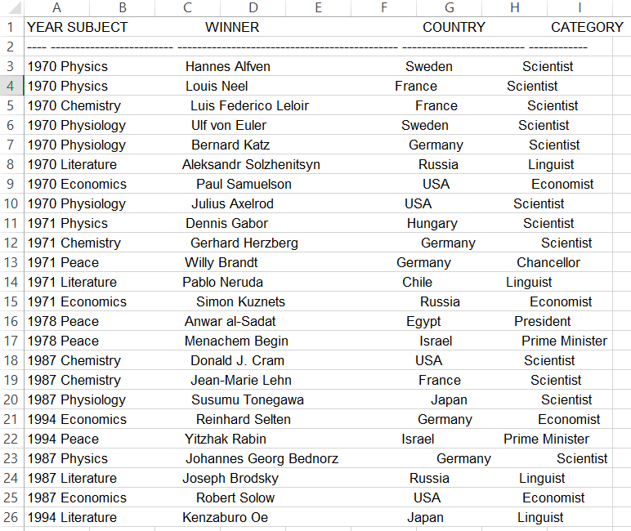

1. From the above table, write a SQL query to find the Nobel Prize winner(s) in the following years (Return year, subject and winner) :
   1. 1970
   2. 1987
2. From the above table, write a SQL query to find the Nobel Prize winner in 'Literature' in the year 1971. Return winner.
3. From the following table, write a SQL query to find the Nobel Prize winner 'Dennis Gabor'. Return year, subject.
4. From the following table, write a SQL query to find the Nobel Prize winners in 'Physics' since the year 1950. Return winner.
5. From the following table, write a SQL query to find the Nobel Prize winners in 'Chemistry' between the years 1965 to 1975. Begin and end values are included. Return year, subject, winner, and country
6. Write a SQL query to show all details of the Prime Ministerial winners after 1972 of Menachem Begin and Yitzhak Rabin.
7. From the following table, write a SQL query to find the details of the winners whose first name matches with the string 'Louis'. Return year, subject, winner, country, and category.
8. From the following table, write a SQL query to find the details of the Nobel Prize winner 'Johannes Georg Bednorz'. Return year, subject, winner, country, and category.

3.

1. Create a database with the name: AbleJobs
2. Create the following Table with the name: Orders

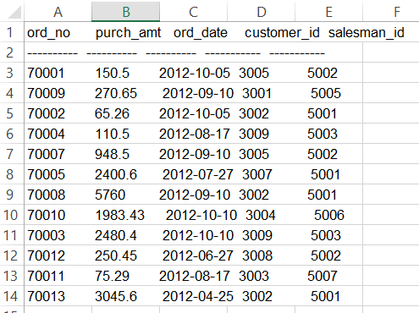

1. From the following table, write a SQL query to calculate total purchase amount of all orders. Return total purchase amount.
2. From the following table, write a SQL query to calculate average purchase amount of all orders. Return average purchase amount.
3. From the following table, write a SQL query to count the number of unique salespeople. Return number of salespeople.
4. From the following table, write a SQL query to count the number of customers. Return number of customers.

# Session 5: Union and Join

1.

1. Create a database with the name: AbleJobs
2. Create the following Table with the name: Nobel



1. From the above table, write a SQL query to combine the winners in Physics, 1970 and in Economics, 1971. Return year, subject, winner, country, and category.

2.

1. Create a database with the name: AbleJobs
2. Create the following Table with the name: Sales2



1. Create the following table with the name: Sales1



1. From the above tables write a SQL query to find the salesperson and customer who belongs to same city. Return Salesman, cust_name and city.
2. From the above tables write a SQL query to find the salesperson(s) and the customer(s) he handle. Return Customer Name, city, Salesman, commission.
3. From the above tables write a SQL query to find those salespersons who received a commission from the company more than 12%.
4. From the following tables write a SQL query to find those salespersons do not live in the same city where their customers live and received a commission from the company more than 12%. Return Customer Name, customer city, Salesman, salesman city, commission.

# Session 6 & 7: Nested Queries & Normalization

Consider a database for an online bookstore. The database consists of two tables: Customers and Orders. Here are the structures of the tables:

**Customers Table:**

CustomerID CustomerName City

1 John Smith New York

2 Jane Doe Los Angeles

3 Bob Johnson Chicago

**Orders Table:**

OrderID CustomerID Product Quantity Price

1 1 Laptop 2 340

2 1 Printer 1 240

3 2 Smartphone 3 70

4 3 Tablet 2 80

Question 1:

Retrieve the names of all customers who have placed an order for a product with a price greater than $100.

Question 2:

List the products that have been ordered by customers from the same city as customer 'John Smith'.

Question 3:

Find the order IDs and total order amounts for orders that contain at least one product with a quantity greater than 2.

# Extra Practice Exercises/Test:

* <https://www.w3schools.com/sql/trysql.asp?filename=trysql_asc>
* <https://sqlzoo.net/wiki/SQL_Tutorial>
* <https://app.testdome.com/t?GeneratorId=12>

# 

# Online SQL editor for Self-Practice:

* <https://www.mycompiler.io/new/sql>
* <https://www.sql-practice.com/>
* <https://www.jdoodle.com/execute-sql-online/>

| Submit your Homework in this google form: <https://forms.gle/RiSKpYgrxhzGffwq7>  To submit your Project follow the steps mentioned in this doc. [User's guide - SQL](https://docs.google.com/document/d/1hEuGXv6GZ_Ug79rLiYC7serP-iJ6HHcnMIOawm59XyE/edit#) |
| --- |